GAD415 Readings & Assignments: Week 2
Week 2 Reading
Complete the following reading early in the week:
- Week 2 online lectures.
- From the textbook, Modeling a Character in 3ds Max:
  - Chapter 3: The Guide Objects
  - Chapter 4: The Head and The Face
  - Chapter 5: The Hair
- Review the textbook 3ds Max 2010 Bible, as needed to reinforce and expand on the concepts and techniques required for this week’s assignments.
Week 2 Assignments Overview
Assignment Summary: Week 2 | Due Date
Assignment 1: Discussion Questions | Tuesday, April 13, 2010
Assignment 2: Final Project—Getting a Head | Tuesday, April 13, 2010
Assignment 3: Final Project—Modeling the Hairdo | Thursday, April 15, 2010
Assignment 4: Exploring 3ds Max | Saturday, April 17, 2010
Using the navigation on the left, please proceed to the next page.

Week 2 Overview
Last week, you learned the basic methods of 3D modeling and how they apply to low-poly video game character creation. You discussed character sketches and their role in character design process. You also learned in detail about creating model sheets and using scans in modeling. Finally, you looked at some low-poly modeling methods and challenges.
This week, the course covers the process of developing character designs using sketches and model sheets. You'll create reference bitmaps from scans or scanned images of these sketches and position them in the viewports in preparation for modeling.
Learning Outcomes:
- Conceptualize 3D coordinate systems and construct 3D models.
- Create low poly models using box modeling techniques.
- Adjust polygon count based on changing requirements.
- Control polygonal face count through the various object parameters, such as segments and sides of primitives, path and shape steps for loft objects and tessellation controls for some modifiers.
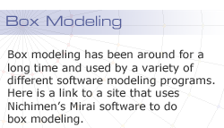
Box Modeling Techniques—Overview
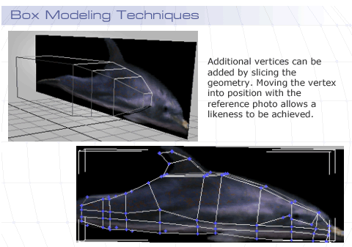
The games industry has been around long enough that you can examine the difference between “traditional” and modern techniques for modeling. Five or ten years ago, game platform requirements severely limited the polygon count of game characters, and modelers utilized a technique referred to as “box modeling,”named because modelers started with a box. By adding vertices and faces through various techniques, they could build the complexity of the model while maintaining a low-polygon mesh count. Pushing and pulling vertices in the viewports would eventually shape the model into the form of their choice. Often, the 3D box had a wire frame material applied to it, so the modelers could see through the surfaces to a plane, using a reference sketch or photo.
In this week's lectures, you'll look at the traditional box modeling toolset, Editable Mesh and then explore the more modern evolution of the same tool through Editable Poly. You'll learn to model a character with these tools and understand what each does and how to use it.

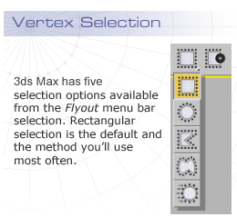
Vertex Selection and Manipulation
Vertices can be moved, rotated, and scaled just like objects. They display the transform gizmo and use the various Reference Coordinate Systems independently for each transform. You need to use consistent habits when you select vertices to transform. Try to work in orthogonal views like Front and Left, rather than in the Perspective viewport. Doing so will help you keep your vertices linked up evenly in your model. Also, you need to be careful that you select only the vertices that you want; it is easy to select additional vertices without realizing it or think you have selected multiple vertices when you haven't.
You can select and move a single vertex by clicking on it, but often you want to move the vertices in pairs, so drag out a selection window to select the vertices, instead of clicking on those vertices. The Ignore Backfacing command will also affect this. If you have Ignore Backfacing turned on, a selection window will only select the vertices facing the active viewport. Turn Ignore Backfacing off when you want to select pairs of vertices on either side of the model.
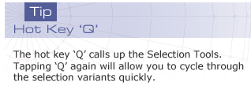
Ignore Backfacing controls whether your selection is limited to the vertices facing you. Turn this control on to make sure you don't select unseen vertices in the viewport. Turn the control off, when you know you want to get vertices on both sides of the model.

Circular selection is an unusual variant that is useful for occasional use when you want to select or deselect a circular area of vertices.
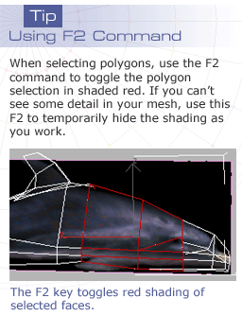
3ds Max includes a Fence and Lasso selection tool from the same menu that lets you create irregularly shaped areas of vertex selection by clicking or drawing a shape. The new Paint Selection tool also lets you create irregular selections by painting directly on the mesh. You can add or subtract to selections using the CTRL and ALT keys, respectively.
One last important selection option to understand is Window or Crossing. While this option doesn't apply to vertex selection, it becomes important when you are selecting all the other sub-objects. In the main toolbar, the Window/Crossing option toggles between these two selection types. When Window is turned on, only the sub-object completely within the selection window is selected. When Crossing is turned on, any sub-object that is within the selection or crossed by the selection window is selected. Often, you can switch between Window and Crossing while you're working, using Crossing to add to selections and then switch to Window to subtract them.

Mastery of 3ds Max selection tools is critical to good modeling. You'll introduce errors into your work if you don't know how this selection operates, because you'll select and transform vertices without knowing those vertices, and you might distort your model
. 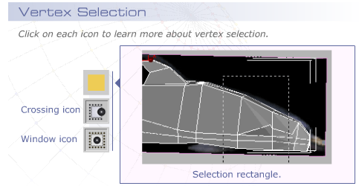
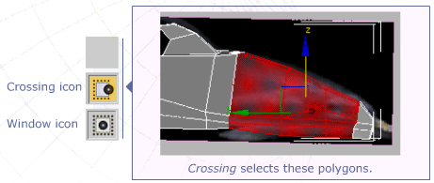
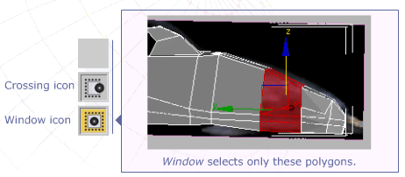

Soft Selection
One of the most powerful techniques in 3ds Max is the use of soft selections. This technique allows you to manipulate your sub-object selections and have them influence the nearby sub-objects to a greater or lesser degree through a soft selection falloff. This lets you move vertices and have the neighboring vertices shift out of the way as you work, preventing you from creating overlapping geometry and intersecting faces. A rainbow display shows the falloff.
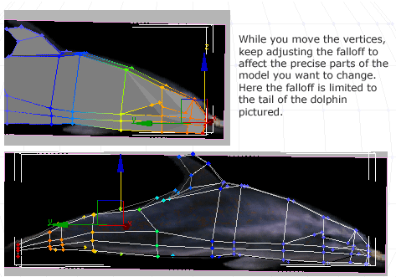
The window in the Soft Selection rollout shows the cross section of the shape of the influence of the Soft Selection modifier on the object.
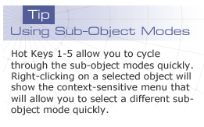
Edit Mesh Modifier/Editable Mesh Objects
3ds Max is actually just a place for plug-ins to play. Everything you see in the modifier stack is a plug-in. When 3ds Max makes a box, internally it finds the“Box” plugin and then runs it with the chosen parameters. This allows for all kinds of interesting animation possibilities, as nearly every parameter of every plug-in can be made animatable. For modeling purposes, however, you need to access the object as a collection of vertices and surfaces in space. To do so, you can use the Edit Mesh modifier or Editable Mesh Object. By placing an Edit Mesh modifier on a Box in the viewport, you can now choose subobject selections, such as Vertex, Edge, Face, Polygon, or Element. If you have made a subobject vertex selection, for example, the stack displays dots to the right of the Vertex entry and indicates that it is passing that selection up the stack. This is important if you use other modifiers on top of the Edit Mesh modifiers, for the modifiers will only be applied to the selected vertices, and not the whole object.

Note: In 3ds Max 4, an Editable Poly Object was added that shared many of the characteristics of the Editable Mesh Object. In 3ds Max 7, an Edit Poly modifier was added that is similar to the Edit Mesh modifier. Of course since Editable Poly is a later addition, it has more features than its Mesh counterpart. You'll review the Edit Poly/Editable Poly object tools in the next lecture topic.
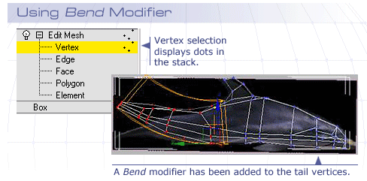
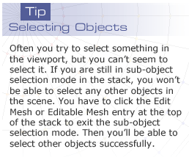
Using an Edit Mesh modifier, will maintain the Box parameters, and you can highlight the Box in the modifier stack and change its options, such as adding more segments or changing the length, width, or height. Use this modifier when you haven't made up your mind about these options and don't want to commit to them.
Alternately, you can take the parametric object and convert it to an Editable Mesh Object. Select the object in the viewport, then right-click, and choose Convert To—> Convert To Editable Mesh. You can also right-click the Edit Mesh modifier in the stack and choose Collapse To, which will do the same thing, namely convert the object to the Editable Mesh Object.
The Editable Mesh Object will have the same subobject selections available as the Edit Mesh Object, but you won't have the underlying Box anymore. There will no longer be any Box parameters to change; you'll only have the Vertex/Edge/Face/Polygon/Element selections.
Using Editable Mesh has one advantage over using Edit Mesh modifier. It should give the fastest viewport performance. When you have lots of characters and objects in the scene, and these objects have many modifiers in their stacks, performance will start to slow down.
You'll have problems getting real-time animation out of these characters, as well as general viewport navigation slowness. When you run into these issues, consider collapsing to Editable Mesh Object and see if you get some improvement. You'll lose any subobject animation you may have, so don't collapse or convert when that's the case.

Editable Mesh/Edit Mesh Tools
There are some excellent tools that form the basis of Box Modeling. Some of these tools are available for all subobject selection levels; other tools are only associated with certain levels. Rather than organizing these by subobject level, we'll look at each in detail:
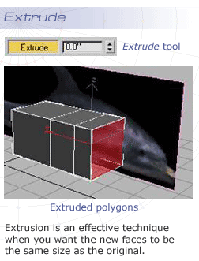
Extrude
The Extrude tool lets you extend the geometry. Commonly you extrude at the polygon level, selecting a single polygon and extruding it a distance along its face normal. You can extrude by clicking the extrude button in the rollout. Then by dragging in the viewport or by entering a value in the Extrude field, you set the amount of the extrusion. The extrusion moves the selected polygon or face the defined distance and creates new faces from the original mesh to the new face position. You can also extrude by clicking the extrude spinner.
Note: The advantage of using the spinner over the select and drag method is that you can more accurately make adjustments on the fly; the click and drag method ends the operation. The next time you click and drag, you'll be starting the operation again and adding more polygons to your model.
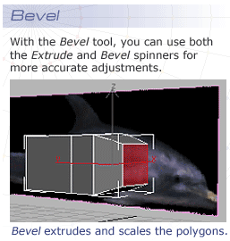
Bevel
The Bevel tool is used more than the Extrude tool. Bevel lets you do exactly the same operation as an extrusion, but then when you lift your mouse button, you perform an additional scale on the extruded polygon. This tool is very handy when you are creating the organic shapes of a character since rarely does the organic shape stay constant.
Extrude and Bevel are both very basic tools in Edit Mesh/Editable Mesh. They have added functionality in the Edit Poly versions with a mode that lets you try out changes before committing to them. For this reason, it's often a good idea to Convert to Editable Poly or use the Edit Poly modifier instead of the Edit Mesh/Editable Mesh tool.
Note: Instead of planning to do something and then doing it, committing lets you do something, try it out while you are doing it, and see the results. If you like the results, you press OK and you're done. If you don't like the results, press cancel and then the changes disappear. This process is known as committing.
Since most of these tools work better in Edit Poly/Editable Poly modifier, let's look at these tools in the Edit Poly/Editable Poly section that follows.


Editable Poly/Edit Poly Modifier
3ds Max has its roots in Autodesk 3d Modeling, an animation product for DOS called 3D Studio. First released in 1990, this product was essentially a face-modeler, as everything was built out of triangular faces. That was so because the triangle is the most basic shape that defines 2 dimensions in space. When 3ds Max was released for Windows NT, it was still a face-modeler. All polygons were actually pairs of triangular faces. It wasn't until version 4 of 3ds Max that true polygon modeling was introduced. The Editable Poly object was introduced; it allowed for polygon objects of any number of sides. In this type of object, the triangles were removed essentially. The triangles are still there, but hidden to simplify the visual complexity for the artists; this point is very important when determining polygonal counts for games models.
At that time, NewTek's Lightwave software offered superior modeling capabilities, and these features were studiously copied by the developers of 3ds Max and integrated into the 3ds Max product. The features were welcomed by the community of 3ds Max artists, but there were complaints that they didn't offer a modifier version of Editable Poly. Finally in 3ds Max 7, the Edit Poly modifier was released, more or less completing the evolution of the tool.
We'll continue a discussion of these chief box modeling tools and techniques using the Editable Poly and Edit Poly versions
Extrude and Bevel
The Extrude and Bevel commands found in Edit Mesh made a big improvement in Editable Poly. The Settings button on the right of the tool opens a dialog box. In the dialog box, you can try different settings for the parameters, and see the effect in the viewport before you commit to the change by pressing OK or Apply. In addition, you have an Apply button, so you can perform operations quickly and repeatedly.
Michael Comet’s head modeling tutorial:
http://www.comet-cartoons.com/3ddocs/headpolymodel/
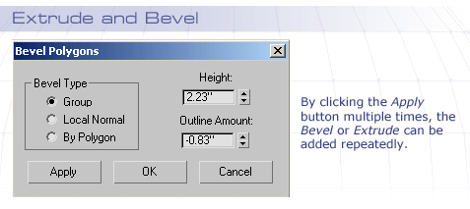
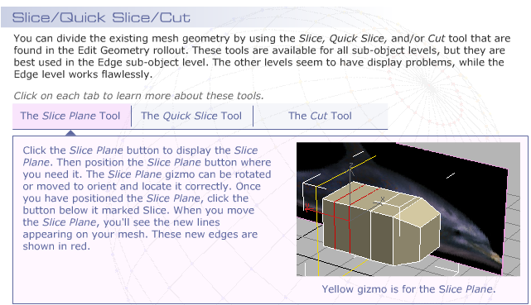
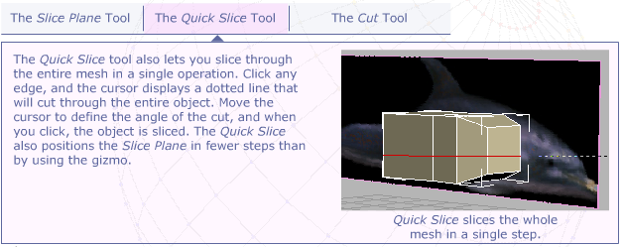
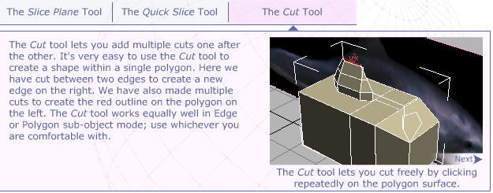
TIP: Most tools like these are “sticky.” They stay turned on after each use. You need to remember to click on them again to toggle them off when you are finished; otherwise, you might not be able to access the next tool you want to use. If a tool doesn't toggle off, click at the object level in the stack to disengage it.
Inset
The Inset tool is the same as Bevel with a height of zero. It simply takes the polygon and creates a smaller version of it within the same plane as the original. Unlike Bevel or Extrude, it keeps the new polygons on the same plane as the original.
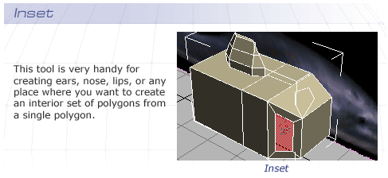
Vertex and Edge Chamfer
One of the most useful box-modeling tools is the chamfer. Chamfer essentially replaces the selection with a polygon. A Vertex Chamfer, for example, takes the original vertex and turns it into a polygon bounded by four vertices. The Chamfer amount determines the distance that the four vertices have moved away from the original position. The Chamfer will follow straight down the connected Edges all the way to the next Vertex along that particular edge and then stop and weld the vertices on completion of the operation.

A Word of Caution
Check the new welded vertices when chamfering. Sometimes the weld operation is not completed, and you'll have a microscopic face inadvertently hidden in your model. This situation can be due to a tiny slip of your hand at the last second or the tolerance setting for welding may be set too low for the object you are working on. Always check by clicking on the suspected vertex and moving it; then click on the Undo button to put it back where it belongs. If the vertices did not weld together properly, drag a selection window around the vertices, and then click on Weld.
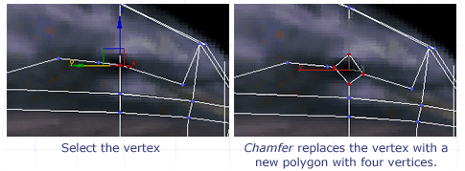
Additional Edge Tools
Working with Edges is a very useful way to model. Using edges instead of vertices adds power to your arsenal of tools and increases your sculpting vocabulary. Edges have additional selection tools that can help you in your character modeling workflow, thus speeding up the process of creating your design. Tools like Ring,Loop, Shrink, and Grow can make a big difference in the way you model.
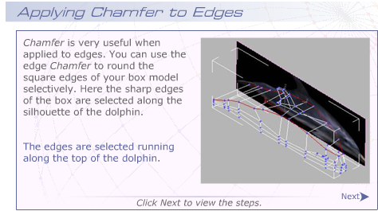
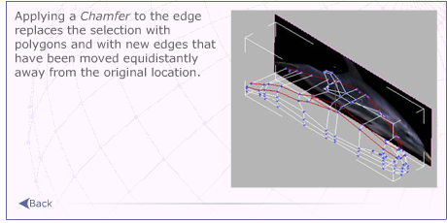
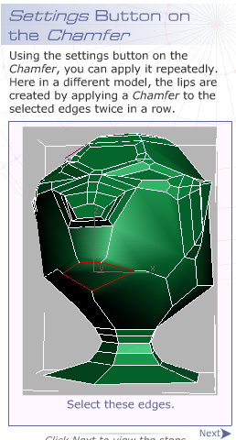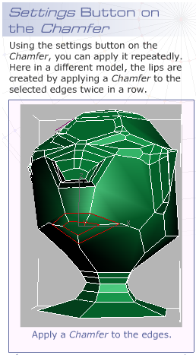

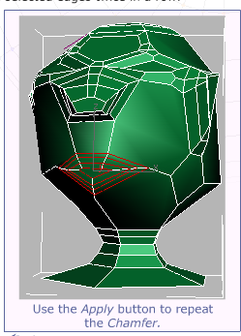
Edge Selection Tools
Loop and Ring
When your model has a regular structure, if you select an edge, 3ds Max can sometimes recognize that this edge is only part of a pattern. Click an Edge, and then choose Loop or Ring, and see the results. The Loop and Ring mode depends on a clean poly model. Both tools will follow either along the length of connected edges of Quad polygons (Loop) or across to the opposite sides of adjacent Quad polygons (Ring) all the way around the model until it loops back on it or runs into an “illegal” (non-quad) polygon. This is another reason for keeping your polygons“legal.”
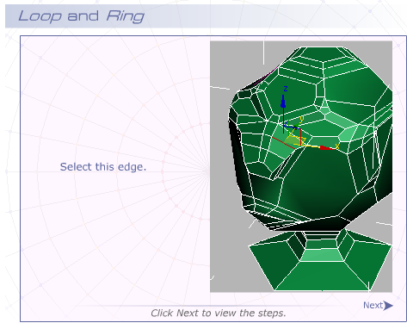
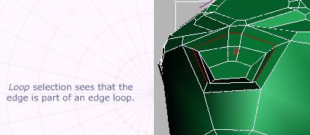
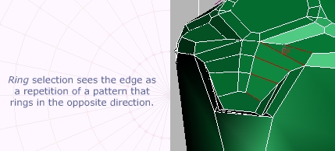

Shrink and Grow Selections
Shrink and Grow are two more selection methods that Editable Poly objects provide. If you have a single polygon selected, the Grow button will select all the polygons that touch the original.
The Shrink feature reverses the process. If you have an area of selected polygons, the Shrink feature subtracts the outlying polys, leaving only the interior ones selected.
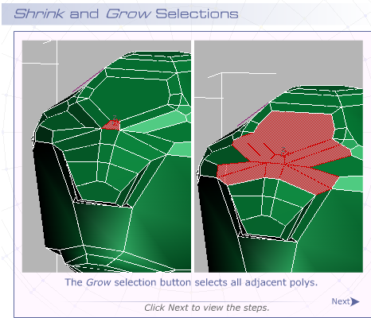
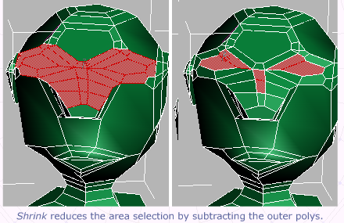
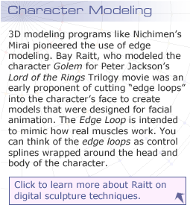
In 3ds Max, there is now a Paint Selection icon on the Selection flyout of the Main Toolbar.
Paint Selection
Paint Selection lets you create selection sets by painting on the surface of the model, using a brush as the selection mechanism. This process works well for selecting vertices, but it's tricky to use to select polygons, depending on the videocard drivers for your particular system.
Digital Sculpting Techniques:
http://www.ogle.com/articles/digital_sculpting.pdf
In 3ds Max, there is now a Paint Selection icon on the Selection flyout of the Main Toolbar.
Paint Selection
Paint Selection lets you create selection sets by painting on the surface of the model, using a brush as the selection mechanism. This process works well for selecting vertices, but it's tricky to use to select polygons, depending on the videocard drivers for your particular system.
You can turn edges to build edge loops or simply to follow the contours of the form.
Many tools and materials operate on visible edges, so it's handy to know how to change the edge loops. For instance, a wireframe material will only display on visible edges. A Lattice modifier will create geometry on visible edges as well.
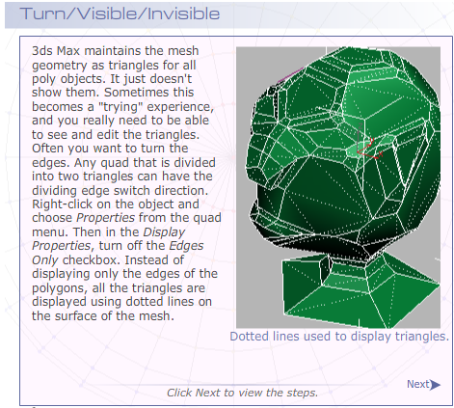
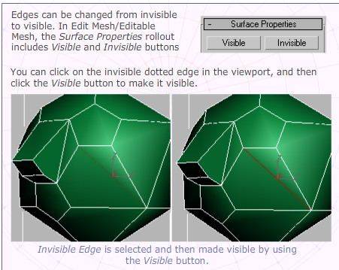
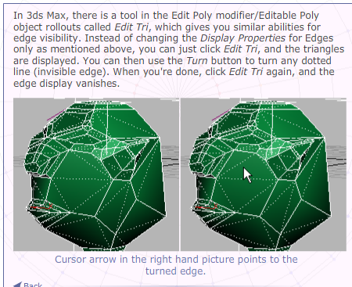

Edge Remove
One of the best reasons to use Edit Poly over Edit Mesh is the Remove command for Edge and Vertex subobjects. Before Editable Poly was around, if you deleted an edge, the polygon disappeared too. Now there is a button called Remove, which will eliminate the edge from the display without interfering with the surface. You can remove edges and vertices to lower the polygon count and the vertex count of your object to satisfy the demands of the game engine. Be careful though. You need to maintain 4-sided quads. 3ds Max will let you remove edges to your heart's content, but that won't be all you need to do. You'll have to do a Vertex Remove then to clean up vertices left behind and use Edit Tri to verify you have 4-sided quads only. Many game exporters will have trouble dealing with polygons of more than 4 sides. To add edges, use the Cut tool; to add vertices, use Insert Vertex in the Edit Edges rollout of the Edit Poly modifier.
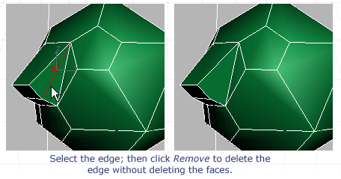
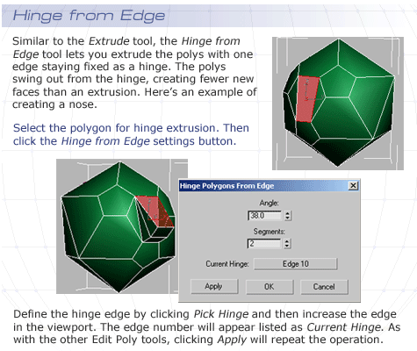
Paint Deformation
With the popularity of the modeling program Z-Brush, paint deformation has become a requirement for the modern 3D package. In an effort to keep up with the competition, there is now a Paint Deformation rollout with Push/Pull and Relaxoptions. You can paint directly on the surface of the model in the viewport and move the polygons, based on the values set in the Paint Deformation rollout. The direction can be defined, based on the normals or by using a selected axis.
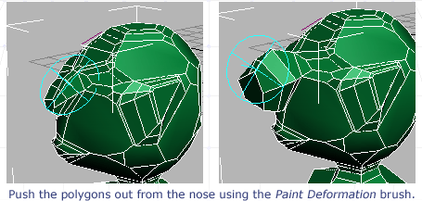
The Relax option is another choice for the Paint Deformation tool. This option makes your mesh structure more regular by shifting the vertex positions slightly and subtly.
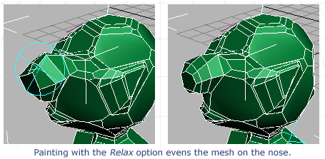
Use the Relax option in the Paint Deformation tool to normalize the distance between vertices. Vertices positions are usually averaged to give a more even and relaxed look to the mesh.

Using the Polygon Counter
There is an important utility called Polygon Counter in 3ds Max that you can use to assist you in your low-poly modeling. On the Utility panel, click the More button, and then choose Polygon Counter from the list. The Polygon Counter utility will appear. You can keep this counter up while you're working, and the counter utility will monitor the polycount of the selected objects and all the objects in the scene.
You can set up a polygon or triangle budget for your object. In this course, you've designed a character with a target count of 1,000 polygons. A thermometer display will show as red when you have exceeded your limit. You can choose between the triangle or polygon count at the bottom of the utility. When polygon is selected, the numbers for the objects (selected and total) reflect the number of polygons rather than the triangles.
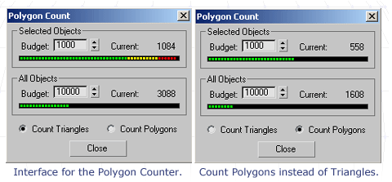
There is also a heads-up viewport display for viewing the polygon count. If you press “7” on the keyboard, the selected object will display the number of faces (polygons) in yellow under the viewport label. If you want a heads-up display of the faces, there is a Triangle Counter to use instead. You'll have to assign a hotkey or a shortcut key for this counter because as a default it is unassigned. Go toCustomize —> Customize User Interface; then in the Keyboard Tab find Triangle Counter in the Action List. Click in the Hotkey field, and then press the keystroke combination you want to assign.

Symmetry Modifier
Usually, most modelers only create one half of a model and then use some method to mirror it around an axis to create the corresponding half. The Symmetry modifier will do this task for you conveniently. It gives you a gizmo to adjust the position and orientation of the mirror plane and includes an option to automatically weld the seam. This process is a good way to work because it sets your model up for texturing with a seam down the front.
Tip: Clicking the Show End Result toggle under the Object Stack display allows you to work on the Editable Mesh or Editable Poly subobject level of the original mesh below the Symmetry modifier and also see it updated on both sides.
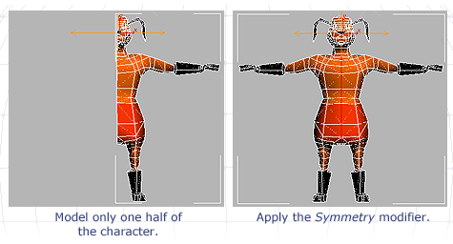
If the evenness of the model bothers you, you can add additional modifiers to make the character less symmetrical. Adding a Noise modifier can add random deformation as well, or you can apply an Edit mesh/Edit Poly modifier to push and pull the vertices.
Meshsmooth vs. MSmooth/Turbosmooth
A common technique used by modelers is to start with a very low-poly structure and then apply a subdivision surface application that smooths the geometry by replacing the edges with faces. 3ds Max has had this functionality for a long time as the Meshsmooth modifier. If your object is angular, you can derive a smoothed object quickly by using this operation. Here, a Meshsmooth modifier is applied to a box and set to 2 iterations.
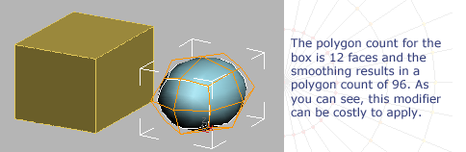
In 1997, Pixar Animation Studios created a short film called Geri's Game that won an Academy Award. It featured the character of an old man playing chess with himself. The character was created using subdivision surfaces. Click here to see the movie.
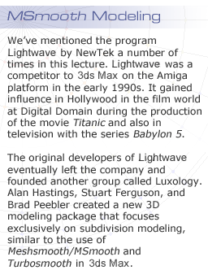
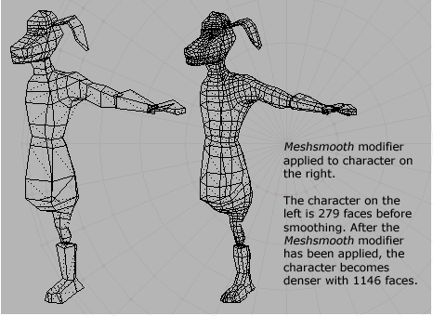
If your model is not sufficiently angular, you don't get much benefit from theMeshsmooth, and you can end up with a much higher polygon count. This result makes the use of this modifier a bad idea when applied to the entire mesh. You can have better results by applying it to only a selected portion of the mesh. Use any sub-object selection, and then apply the modifier and turn off Apply to Whole Mesh in the Subdivision Method rollout.
Edit Poly and Editable Poly objects have an MSmooth button that lets you apply aMeshsmooth type operation to the subobject selection automatically. This is not a parametric operation. Once you apply the MSmooth operation, there is no place in the stack that stores this for later removal. Use this MSmooth operation selectively to smooth out areas in a more limited fashion. Notice that the MSmooth operation also subdivides neighboring polygons as well as ones within the selection set.
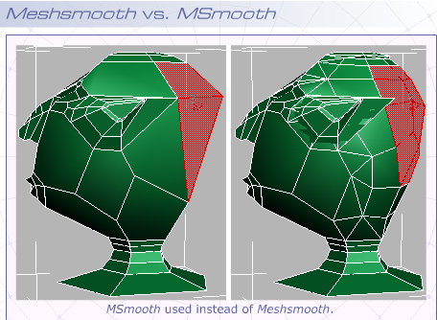
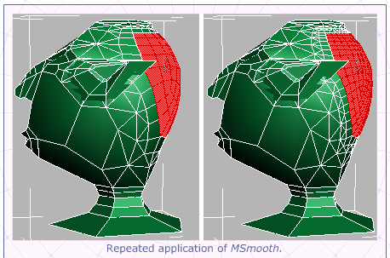
Clicking the Apply button multiple times repeats the operation. This is a bad idea unless you have good reason to repeat the task.
3ds max comes with a new version of the Meshsmooth modifier calledTurbosmooth. It's Meshsmooth rewritten for speed and performance. It has fewer options, but uses memory much more efficiently, so your viewport performance doesn't suffer the way it can with Meshsmooth. These tools are really much more suited to the character animator working in film or rendering cut-scenes. For the low-poly modeler who is creating a game character for export, these tools must be used judiciously and with a cautious hand.
More about modeling: http://www.luxology.com/community/
MeshSmooth Tutorial: http://www.comet-cartoons.com/3ddocs/bodymodeling
Summary
In the past week, you've taken an extensive look at the box-modeling method of low-poly character modeling. You've had a chance to review the methods used for vertex selection, so you know when to select the vertices you want to select and when to avoid selecting vertices throughout the model by using the Ignore Backface command. You've also looked at Soft Selection, so you can move vertices and have the neighboring elements move out of your way as you do.
The basic tools for box-modeling have been shown using Edit Mesh and Edit Poly commands. In Edit Mesh, you saw how to use Extrude and Bevel, probably the most commonly used tools to build low-poly characters. In Edit Poly, you saw the improved workflow offered by the settings button that will let you try out your changes before you commit to them and also lets you apply them repeatedly with the Apply button. Also in Edit Poly, you worked with the Slice, QuickSlice, and Cuttools to add edges where you need them and Vertex Chamfer to replace vertices with polygons. This is particularly useful for eye sockets and any places where you want to round a sharp edge.
You saw the use of Edit poly selection tools, such as Loop, Ring, Grow, Shrink, and how they can aid in the process of building edge loops in your mesh character. Other Edge tools, such as Edge Turn and Edge Visibility buttons, were covered. The use of Edge and Vertex Remove as the primary method of doing low-poly reduction was dealt with as well. Other tools that we looked at included Hinge from Edge to build noses and ears. The Paint Deformation tool, a new function in 3ds Max was also discussed. Use this tool to model by using a paintbrush interface, painting directly on the 3D model to push or pull geometry, or applying a relax operation.
The very important polygon counter was a utility you examined; it lets you monitor your polygon budget for selected objects and the entire scene as you work. You also discussed the Symmetry modifier, which you can use to create bilaterally symmetrical characters by only modeling one half and creating the second half automatically.
Lastly, the tools that let you smooth your geometry were compared. Meshsmooth, the original modifier, can be applied to the whole object or just a portion of the mesh to provide a parametric replacement of edges with faces and smooth the silhouette of your model. MSmooth, the subobject tool, lets you apply aMeshsmooth operation to a selection and smooth during modeling. Once applied,MSmooth cannot be turned off like a modifier can be, so this technique is useful only when you know what you want to do. Turbosmooth is a streamlined updatedMeshsmooth with fewer parameters and a better memory footprint.
Next week, you'll look at spline modeling methods, such as Lofting and SplineCage Modeling. You will also investigate basic methods of object optimization by using modifiers, such as Optimize and MultiRes, and also edge and vertex removal within Edit Poly.
Your ultimate goal in this class is to produce a low-poly character model under 1,000 polygons.
Download Josh Jones Guest lecture on polymodeling:
http://webuploadcontent.next.ecollege.com/pub/content/700d5853-9e6e-4f10-abf6-fb8964d9f925/GAD415_W2_GuestLecture.pdf?eclg_res=250784&eclg_resver=342238

Assignment 1: Discussion Questions
By Tuesday, April 13, 2010, respond to the discussion questions assigned to you by your facilitator. Submit your responses to the appropriate Discussion Area. Start reviewing and responding to your classmates' discussions as early in the week as possible.

Grading Criteria | Maximum Points
Response Criteria.
Met the criteria for the correct responses to the questions assigned. | 6
Used vocabulary relevant to the current week's topics—at least five terms. | 6
Participation Criteria.
Used vocabulary relevant to the current week's topics—at least five terms. | 6
Participated in the discussion by asking a question, providing a statement of clarification, providing a point of view with a rationale, challenging a point of discussion, or drawing a relationship between one or more points of the discussion. | 6
Justified ideas and responses by using appropriate examples and references from texts, Web sites, other references, or personal experience. | 6
Total: | 30
For assistance with any problems you may have when completing this assignment—OR—to offer your assistance to classmates, please use theProblems and Solutions Discussion area located through the left side navigation link.
DQ1 - What techniques work best for “hard surface” modeling, such as levels and props? Why are some techniques to be avoided? What are the consequences of not avoiding these techniques? Do you agree with your peers' responses? Why or why not
DQ2 -Compare and contrast the Editable Mesh/Edit Mesh modifier with the Editable Poly/Edit Poly modifier for box modeling. What are the advantages and disadvantages of using both?
DQ3 - How can Meshsmooth be used to the best advantage for low-poly modeling? Do you agree with your peers' responses? Give reasons.
DQ4 - Compare and contrast box modeling, spline cage modeling, and NURBS on the basis of the following parameters:
- Low-poly models
- Organic curves
- Performance issues
Create a table with three columns, and list your analysis of each aspect based on the parameters listed above.
Research by using Web sites, journals, and magazines; cite your references while providing a comparative analysis of the three modeling techniques.

Assignment 2: Final Project—Getting a Head
Model your game character's face and head by using Low-Poly Box Modeling techniques. Work on this model for several consecutive sessions, so you can revise it and try out different ideas. Every time you work on the game's character again, it'll be considered as a new session. The work could be an hour later, several hours later, a day later, or several days later.
By Tuesday, April 13, 2010, post the game character's face and head to the appropriate Discussion Area.
Post at least three work-in-progress .MAX files to demonstrate your Final Project work.
Grading Criteria | Maximum Points
Created the head of a character complete with facial features. | 8
Modeled the head by using box modeling techniques, such ascut and slice, polygon extrusion and bevel, vertex chamfer. | 5
Demonstrated that they modeled the character over several iterative periods, rather than in a single session by posting multiple files. | 8
Posted at least three work-in-progress files to demonstrate the iterative sessions used to complete the model's head. | 4
Total: | 25
For assistance with any problems you may have when completing this assignment—OR—to offer your assistance to classmates, please use theProblems and Solutions Discussion area located through the left side navigation link.
NOTE: There are a lot of points to be earned by working in an iterative fashion, so be sure to post your work in progress as you work. DON’T post your max files all at the same time!
I look forward to reviewing your head models!
- Todd
Assignment 3: Final Project—Modeling the Hairdo
Model your game character's hair, hat, or helmet, using Low-Poly Box Modeling techniques.
Work on your character for several consecutive sessions, so you can revise the model and try out different ideas. By Thursday, April 15, 2010, post your results as a .MAX file to the appropriate Discussion Area.
Post at least three work-in-progress .MAX files to demonstrate your Final Project revisions and the various design ideas you tried out.
Grading Criteria | Maximum Points
Created the game character's face and head with hair, hat, helmet, or some other similarly suitable substitute, such as goggles, headphones, and so on. | 8
Modeled the head by using box modeling techniques. | 5
Demonstrated that they modeled the character over several iterative periods, rather than in a single session by posting multiple files. | 8
Posted at least three work-in-progress files to demonstrate the iterative sessions taken to complete the model's hair do. | 4
Total: | 25
For assistance with any problems you may have when completing this assignment—OR—to offer your assistance to classmates, please use theProblems and Solutions Discussion area located through the left side navigation link.
NOTE: There are a lot of points to be earned by working in an iterative fashion, so be sure to post your work in progress as you work. DON’T post your max files all at the same time!
I look forward to reviewing your hairdo or headdress models!
- Todd
Assignment 4: Exploring 3ds Max
Explore the 3ds max toolset on your own. Explore the various features, actions, menus, and options of the software on your own.
By Saturday, April 17, 2010, post your findings and discoveries to the 3ds MaxProblems and Solutions Discussion Area. Also post the challenges you faced in the entire process and how you tackled those. In addition, also share some tips and best practices with your peers and suggest solutions to the challenges faced by them.
Grading Criteria | Maximum Points
Posted findings and discoveries gained while exploring the 3ds Max toolset. | 4
Actively participated in the 3ds Max Problems and Solutions Discussion Area. | 4
Total: | 8
For assistance with any problems you may have when completing this assignment—OR—to offer your assistance to classmates, please use theProblems and Solutions Discussion area located through the left side navigation link.
NOTE: This is the second time around for this assignment, so it should be more clear what is expected, but be sure to review the information below.
This assignment asks you to explore 3D Studio Max beyond the requirements of your other assignments, and independent of those assignments. Learn something new about the software that will be useful to you, and share it with your classmates.
It also asks you to interact with your classmates, and offer tips and advice. You can ask for input from your classmates, but be sure that you do what is asked in the paragraph above.
- Todd

